BUSARI, AKEEM OLAYINKA
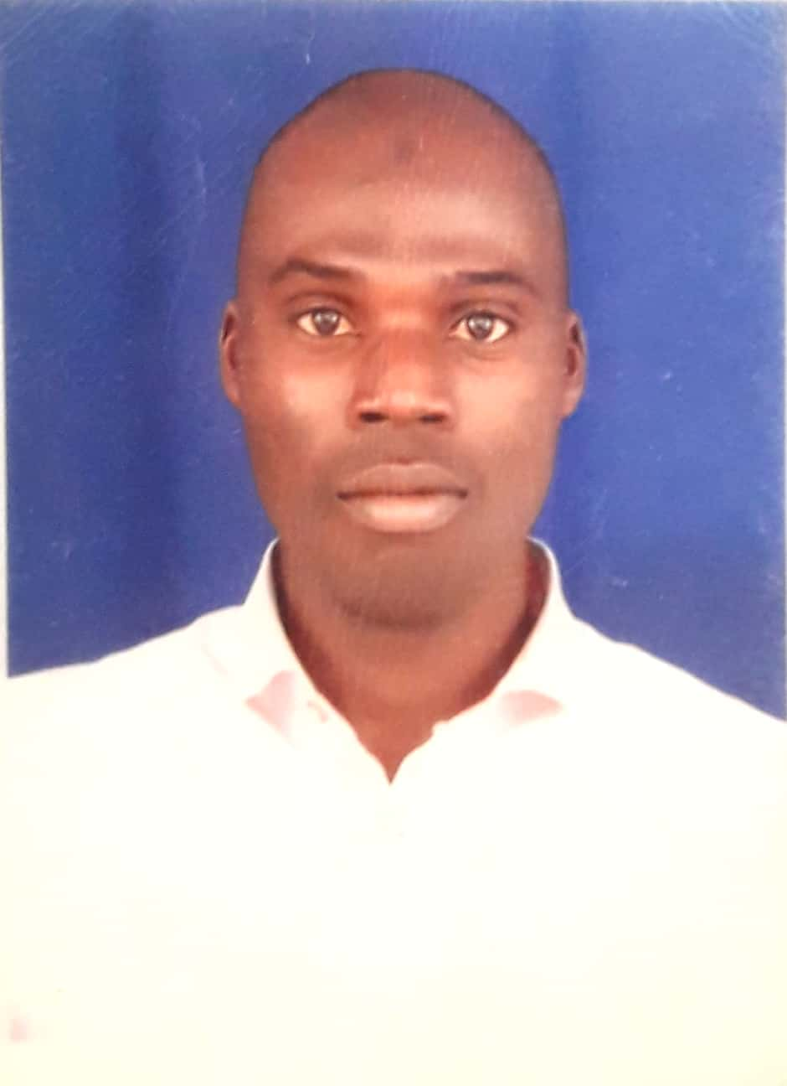
Contact address: Department of Medical Laboratory Science, Al-Hikmah University,
Adewole Housing Estate, Adeta Road, PMB 1601, Ilorin, Kwara State, Nigeria.
Email: busakeem@yahoo.com, Phone number: +2348077609212; +2347060875270

1.0 BIODATA

DATE OF BIRTH: 1st January, 1988

SEX: Male

PLACE OF BIRTH: Igboho

NATIONALITY: Nigerian

STATE: Oyo

LOCAL GOVERNMENT AREA: Oorelope

MARITAL STATUS: Married

CONTACT ADDRESS: Department of Medical Laboratory Science,
Al-Hikmah University, Adewole Housing Estate, Adeta Road, PMB 1601, Ilorin, Kwara State, Nigeria.
+2348077609212; +2347060875270
busakeem@yahoo.com

PERMANENT HOME ADDRESS: Sarumi Compound Isale Ogba, Modeke, Igboho, Oyo State.

NUMBER AND AGES OF CHILDREN:
1. Abdulhakeem Zainab Eniola 2years

PRESENT EMPLOYEMENT STATUS:
Employer: Al-Hikmah University Ilorin
Rank: Lecturer II
Salary Scale: CONUASS 3 Step 2

2.0 INSTITUTION ATTENDED:

Bayero University Kano 2016-2019

National Teachers Institute, Kaduna 2014-2015

Ladoke Akintola University of Technology, Ogbomoso 2006-2011

UMCA Ogunbode Memorial Grammar School, Igbeti 2005-2005

Igboho More Community Grammar School, Igboho 1999-2005

Alagbado-Ode Comprehensive Muslim School, Igboho 1992-1999

3.0 ACADEMIC AND PROFESSIONAL QUALIFICATIOS:

M.Sc. (Chemical Pathology) 2019

Project Management in Global Health (University of Washington) 2019

Diploma in Data Processing and Information Technology 2018

Post Graduate Diploma in Education 2015

Associate of Medical Laboratory Science Council of Nigeria (AMLSCN) 2013

Bachelor of Medical Laboratory Science (BMLS) 2011

Senior Secondary Certificate Examination (NECO) 2005

Primary School Leaving Certificate 1999.

4.0 TEACHING EXPERIENCE:

2020-TILL PRESENT
AL-HIKMAH UNIVERSITY ILORIN, KWARA STATE
Department of Medical Laboratory Science
Lecturer II/Examination Officer/ Al-Hikmah Water Factory Monitoring and Evaluation Advisor / Departmental Quality Assurance Officer/ Academic Level Adviser.
- Coordinate of Lecture, seminars and tutorials
- Design, preparation and development of courses and study materials
- Develop and applying new teaching methods to reflect changes in research
- Rate student coursework
- Set up and mark the exams
- Supervise students’ research, including recent student projects.
- Check on research team, including research assistants.
- Conduct individual research projects and actively contributing to the institution’s research work.
- Write a research paper and make it for publication
- Prepare to finance bids for various research projects in the Department.
- Carry out departmental administrative tasks such as student receptions, induction programs and involvement in committees and boards.
- Contribute to the organization of professional conferences and seminars in my field
- Establish cooperative relations with other institutions, as well as with industry, business and public organizations
- Involve in staff training activities.
2019
KWARA STATE UNIVERSITY, MALETE, KWARA STATE
Department of Medical Laboratory Science
Adjunct Lecturer/ Students’ Project Supervisor
- Coordinate of Lecture, seminars and tutorials
- Design, preparation and development of courses and study materials
- Develop and applying new teaching methods to reflect changes in research
- Rate student coursework
- Set up and mark the exams
- Supervise students’ research, including recent student projects.
4.1 COURSES TAUGHT
MLS 201 Introduction to Medical Laboratory Science I
MLS 202 Introduction to Medical Laboratory Science II
MLS 303 Medical Laboratory Science Ethics
MLS 304 Laboratory Instrumentation, Techniques and Automation
MLS 305 Basic Medical Physics
MLS 309 Basic Clinical Chemistry
MLS 310 Laboratory Management and Organization
MLS 314 Forensic Biochemistry and DNA Techniques
MLS 316 Logistics and Supply Chain Management
MLS 404 Biostatistics and Research
MLS 410 Biomedical Engineering
MLS 411 Analytical Chemistry
MLS 412 Biotechnology and Bioinformatics
MLS 414 Counselling Skills
MLS 415 Nucleic Acid Biochemistry
MLS 416 Immunology and Immunochemistry
MLS 417 Cell and Molecular Biology
MLS 512 Drug Monitoring, Toxicology and Inborn Error of Metabolism
MLS 513 Renal, Liver and Neurochemistry
MLS516 Techniques in Clinical Chemistry

5.0 PROFESSIONAL EXPERIENCE:
2017-2019
KADUNA STATE MINISTRY OF HEALTH AND HUMAN SERVICES
General Hospital Kachia
Chemical Pathology Unit Head / Medical Laboratory Scientist / Logistics Manager / Quality Control Officer/ Scientist in-charge of biochemical diagnosis of HIV/AIDS patients’ sample at Centre for Integrated Health Program (CIHP) Laboratory.
- Conduct chemical analysis of body fluids, including blood and urine to determine the presence of normal or abnormal components
- Operate, calibrate, or maintenance of equipment used in the quantitative and qualitative analysis or computer-controlled analyzers, such as Dimension, Sysmex, Status clinitek, and Biofire touch array.
- Collect and analyze blood samples to determine the number of cells, their morphology, or their blood group, blood type, or compatibility for transfusion purposes, using microscopic techniques.
- Blood Gas Analysis.
- Supervise, train, or direct lab assistants and clinical laboratory technicians or technologists, or other medical laboratory workers engaged in laboratory testing.
- Provide technical information about test results to physicians, family members, or researchers.
- Establish or monitor quality assurance programs or activities to ensure the accuracy of laboratory results.
- Process pathology sample
- Enter data from analysis of medical tests or clinical results into computer for storage.

2014-2017
AMINU KANO TEACHING HOSPITAL, KANO.
Department of Chemical Pathology
Locum Medical Laboratory Scientist / Quality Control Officer / Scientist in-charge of Biochemical analysis of TB/HIV/AIDS patients’ sample at PEPFAR’s Laboratory/ Academic Coordinator of Medical Laboratory Scientist Interns and Students on training.
- Conduct chemical analysis of body fluids, including blood and urine to determine the presence of normal or abnormal components
- Operate, calibrate, or maintenance of equipment used in the quantitative and qualitative analysis or computer-controlled analyzers, such as Dimension, Sysmex, Status clinitek, and Biofire touch array.
- Collect and analyze blood samples to determine the number of cells, their morphology, or their blood group, blood type, or compatibility for transfusion purposes, using microscopic techniques.
- Blood Gas Analysis.
- Supervise, train, or direct lab assistants and clinical laboratory technicians or technologists, or other medical laboratory workers engaged in laboratory testing.
- Provide technical information about test results to physicians, family members, or researchers.
- Establish or monitor quality assurance programs or activities to ensure the accuracy of laboratory results.
- Process pathology sample
- Enter data from analysis of medical tests or clinical results into computer for storage.

2013-2014
AMINU KANO TEACHING HOSPITAL, KANO.
Department of Chemical Pathology
Medical Laboratory Scientist (National Youth Service Corps).
- Conducted medical research under the direction of microbiologists and biochemists
- Collected and processed Patients’ samples for clinical analysis
- Performed internal and external Laboratory quality control
- Performed identification and enumeration of blood cells.

2012-2013
UNIVERSITY OF ILORIN TEACHING HOSPITAL, ILORIN, KWARA STATE.
Intern Medical Laboratory Scientist / Intern in-charge of biochemical analysis of TB/HIV/AIDS patients sample at PEPFAR’s Laboratory.
- Conducted medical research under the direction of microbiologists and biochemists
- Collected and processed Patients’ samples for clinical analysis
- Performed internal and external Laboratory quality control
- Performed identification and enumeration of blood cells.

6.0 ADMINISTRATIVE EXPERIENCE:
Faculty Representative on Student Affairs (2021 till date)
Monitoring and Evaluation Officer, Al-Hikmah Water Factory (2020 till date).
400 Level Students Advisor, Department of Medical Laboratory Science, Al-Hikmah University Ilorin (2020 till date).
200 Level Students Advisor, Department of Medical Laboratory Science, Al-Hikmah University Ilorin (2020 till date).
Department of Medical Laboratory Science Liaison officer with Directorate of Academic Planning on Accreditation and Academic Planning matters (2020 till date).
Examination Officer, Faculty of Health Sciences, Al-Hikmah University Ilorin. (2021 till date)
Examination officer, Department of Medical Laboratory Science Al-Hikmah University, Ilorin (2020 till date).
Unit Head of Chemical Pathology / Logistic Officer at General Hospital Kachia (2017-2018).
MSc. Class Representative (2016-2019)
Laboratory Information System (LIS) Coordinator (2014-2016).
Senior Prefect Boy at Secondary School (2005)
Senior Prefect Boy at Primary School (1999)

7.0 SKILLS:
Strong problem solving and analytical skills.
Excellent communication skills.
Excellent technical writing skills.
Excellent use of software packages such as Microsoft Office (Word, Excel, PowerPoint), SPSS.
Good organizational and managerial skills.
Good interpersonal relationship.
Ability to meet deadlines.
Team-working skills.
Critical thinking skills.
Strong in decision making.
Excellent in Social Media Management.
Highly motivated self-starter.
Excellent Leadership and management skills.
Good Listener.
Handle pressure very well.
Teaching responsibilities to include classroom teaching, online Instruction, practical demonstration and programme evaluation.
Teach distance learning using current online course management systems.
Participate in University, Professional development and Community development.

8.0 MEMBERSHIP OF PROFESSIONAL BODIES:
Associate Member, Medical Laboratory Science Council of Nigeria (AMLSCN: RA 19049).

Member, Association of Medical Laboratory Scientist of Nigeria (AMLSN: MLS/24/01465).

Member, Society of Chemical Pathology Scientists in Nigeria (SCPSN: 114).
9.0 ACHIEVEMENTS:
First to detect diabetic nephropathy earlier with a novel marker (haptoglobin) in African descent.

Among the pioneer team that ensure effective sustainability of Laboratory information system (LIS) in Nigerian Teaching Hospital.

Among the pioneer coordinators of successful online examination in Nigeria Universities.

10.0 SCHOLARLY PUBLICATIONS:

Akinola, F.F, Ogundiran, S.M, Oladapo A.A. and Busari, A.O. (2019). Effect of Caffeinated Drink on Lipid Profile in Alloxan-induced Diabetic Male Albino Rats. International Journal of Advanced Research. 7(8): 258-265. A Publication of International Journal of Advance Research.

Mohammed IY, Busari, AO and Ahmad MB. (2019). Assessing the Clinical Utility of Haptoglobin to Creatinine Ratio as a Test for Detecting Nephropathy among Type 2 Diabetic patients. Journal of Biomedical Research and Clinical Practice. 2(3): 180-184. A Publication of Journal of Biomedical Research and Clinical Practice.

Busari, Akeem Olayinka (2018). Medical Laboratory Science as a career among Secondary School Students in Kano. Bayero Journal of Medical Laboratory Science. 3(1): 7-10. A Publication of Department of Medical Laboratory Science Bayero University Kano-Nigeria

11.0 BOOK PUBLICATIONS:

Chemical Pathology Laboratory Practical Manual. First Edition (2020). ©Adeosun O.G., Yaqub S. A., Busari A.O., Olawuyi A.O., Ajibola K.A. ISBN: 978-978-986-280-1.

Student’s Clinical Posting Log Book. First Edition (2021). © Dr. L.O. Olatunbosun, Dr. M.A. Muhibi, Dr. (Mrs.) R.R. Raheem-Ademola, Mr. L.A. Yunus, Mr. A.O. Busari, Mr. A.O. Olawuyi, Mr. T.G. Oyetunji, Mr. K.A. Ajibola, Mrs. M.A. Kareem, Mr. M.B. Jimoh.

12.0 CONFERENCES/TRAINING/WORKSHOPS ATTENDED WITH DATE:

1. Busari Akeem Olayinka (2020) 2020 Pre-Conference Workshop themed “How to Publish in High Impact Journals” organized by Centre for Research, Industrial Linkage and International Cooperation held at webinar on 6th December, 2020.

2. Busari Akeem Olayinka (2020) 56th Annual Medical Laboratory Scientists Conference themed “Misdiagnosis and Patient Safety in Nigeria Health System: The Medical Laboratory Priority” organized by Association of Medical Laboratory Scientists of Nigeria held at Abakaliki, Ebonyi State, Nigeria on 11th-14th November, 2020.

3. Busari Akeem Olayinka (2020) Pedagogy organized by Centre for Research, Industrial Linkage and International Cooperation (CRIIC) held at Al-Hikmah University Auditorium on 11th-12th November, 2020.

4. Akeem Olayinka Busari (2020) Research Proposal Writing in the Sciences organized by INASP AUTHORAID. 11th November, 2020.

5. Busari Akeem Olayinka (2020) Practical Approach to Strategies for Winning International Research Grants organized by Centre for Research, Industrial Linkage and International Cooperation (CRIIC) held at Al-Hikmah ICT Lab on 7th October, 2020.

6. Busari Akeem Olayinka (2020) Strategies for Winning International Research Grants organized by Center for Research, Industrial Linkage and International Cooperation (CRIIC) held at Al-Hikmah University Auditorium on 24th September, 2020.

7. Busari Akeem Olayinka (2020) Wining International Research Grants organized by Centre for Research, Industrial Linkage and International Cooperation (CRIIC) held at Zoom Platform on 17th August, 2020.

8. Akeem Olayinka Busari (2020) Molecular and Serological Testing for COVID-19. A webinar CME organized by Biomerieux in collaboration with DAKTARI online held on: Thursday 11th June, 2020.

9. Akeem Olayinka Busari (2020) The Book Publishing Process: An Elsevier Author Workshop at Africa. A webinar organized by Researcher Academy on Campus on Wednesday 03 June, 2020.

10. Busari Akeem Olayinka (2020). AMLSN Public Health Lecture organized by Association of Medical Laboratory Scientists of Nigeria held at Lagos on 21st-22nd February, 2020.

11. Busari Akeem Olayinka (2020) 2nd Public Health Lecture themed “One Health Concepts-MLS: The Pivot for Achieving Set Target” organized by Young Medical Laboratory Scientist Forum held at Towlab Hotel and Suites, Akure-Ilesha road, Akure between 7th-8th February, 2020.

12. Busari Akeem Olayinka (2020) Continuous Professional Development (CPD) programme themed “Implementation of Quality Management System in Medical Laboratories Challenges and Prospects” organized by Association of Medical Laboratory Scientists of Nigeria, UITH Chapter in Collaboration with MLSCN. 3rd-7th February, 2020.

13. Busari Akeem Olayinka (2019) 55th Annual Medical Laboratory Scientific Conference themed “Global Health Security: Medical Laboratory Agenda for Sub-Saharan Africa” organized by Association of Medical Laboratory Scientists of Nigeria held at International Conference Centre Abuja. 2nd-6th September, 2019.

14. Busari, Akeem Olayinka (2018). Medical Laboratory Science Profession beyond the bench. Medical Laboratory Science Council of Nigeria (MLSCN) Professional development Programme and Workshop held at National Orthopaedic Hospital Dala, Kano, Kano State, Nigeria 10th – 14th December, 2018.

15. Akeem Busari (2018) 54th Annual Medical Laboratory Scientific Conference themed “Local Vaccine Formulation and Production in Nigeria: Challenges, Threats and Opportunities” held at Jos, Plateau State, Nigeria 11-14th September, 2018.

13.0 THESIS/DISSERTATION/PROJECT:

M.Sc. Dissertation
Title: Evaluation of Urine haptoglobin to creatinine ratio as marker of Diabetic nephropathy among type 2 diabetic patients attending Aminu Kano Teaching Hospital (2018).
Supervisor: Dr. Ahmad. M. B. (Department of Medical Laboratory Science, Bayero University Kano) and Dr. Mohammed I.Y. (Consultant Chemical Pathology, Bayero University Kano/ Aminu Kano Teaching Hospital, Kano)

NTI Project
Title: Medical Laboratory Science as a career among secondary school students in Kano (2015).
Supervisor: Dr. Bello A. (Faculty of Education, Bayero University Kano).

BMLS Project
Title: Effect of Caffeinated Drink on Lipid Profile in Alloxan induced Diabetic Male Albino Rats (2011).
Supervisor: Mr. Akinola. F.F.S. (Department of Medical Laboratory Science, Ladoke Akintola University of Technology, Osogbo, Osun State).

14.0 SPECIAL ASSIGNMENT/COMMUNITY SERVICES:
Monitoring and Evaluation Officer of Al-Hikmah Water Factory, venture of Al-Hikmah University, Ilorin (2021).

Secretary to the Association of Medical Laboratory Scientist of Nigeria, Aminu Kano Teaching Hospital Chapter Building Committee (2016).

Laboratory Information System (LIS) Coordinator at Aminu Kano Teaching Hospital (2015-2016).

15.0 INFORMATION TECHNOLOGY:
Efficient and effective use of Microsoft word package and internet.

Efficient and excellent use of Microsoft Excel and computer software applications package such as SPSS, Epi-info, Instant Graph Pad.

16.0 EXTRA-CURRICULAR ACTIVITIES:
Participating in writing of Medical Laboratory Practical Manual and Work books for Medical Laboratory Science Students.

Engaging in community diagnosis research work.

Writing of Annual Departmental report.

Teaching of Undergraduate Bachelor of Medical Laboratory students

Attending conferences, training and workshop for knowledge upgrading.

REFEREES

Dr. S.A. Nasar
The Head,
Associate Professor,
Department of Medical Laboratory Science,
College of Health Sciences,
Ladoke Akintola University of Technology,
Ogbomoso,
Oyo State.
+23480160865089

Dr. L.O. Olatunbosun
Head of Department,
Senior Lecturer,
Department of Medical Laboratory Science,
Faculty of Health Sciences,
Al-Hikmah University,
Adewole Housing Estate,
Adeta Road, PMB 1601,
Ilorin,
Kwara State.
+2348030467510

Dr. Muhammad Ahmad Bello
Senior Lecturer,
Department of Medical Laboratory Science,
Bayero University Kano,
Kano,
Kano State.
+2348036519640

